NEHA HOSPITAL
MANAGEMENT SYSTEM
Project Plan — Explained in Plain Language
No computer background needed to read this document

1. What Are We Building?
This document explains, in everyday language, the plan for a single website that will run two connected parts of hospital operations: managing staff (attendance, leave, and salary) and managing patients (visits, prescriptions, pharmacy billing, and admissions).
Today, this is done by hand or in scattered Excel sheets. Attendance is read off a biometric punching machine, then someone manually works out salary, fines, and PF/ESI in spreadsheets every month. Patient visits, prescriptions, and pharmacy sales are handled separately with no shared record. The new system replaces all of this with one website that everyone in the hospital — HR, reception, doctors, pharmacists, and administrators — logs into, each seeing only what is relevant to their job.
Think of it as building two “departments” inside one office building. Both departments have their own staff and their own daily work, but they share the same reception desk (the login system), the same filing cabinets (the database), and the same rulebook of who is allowed to do what.
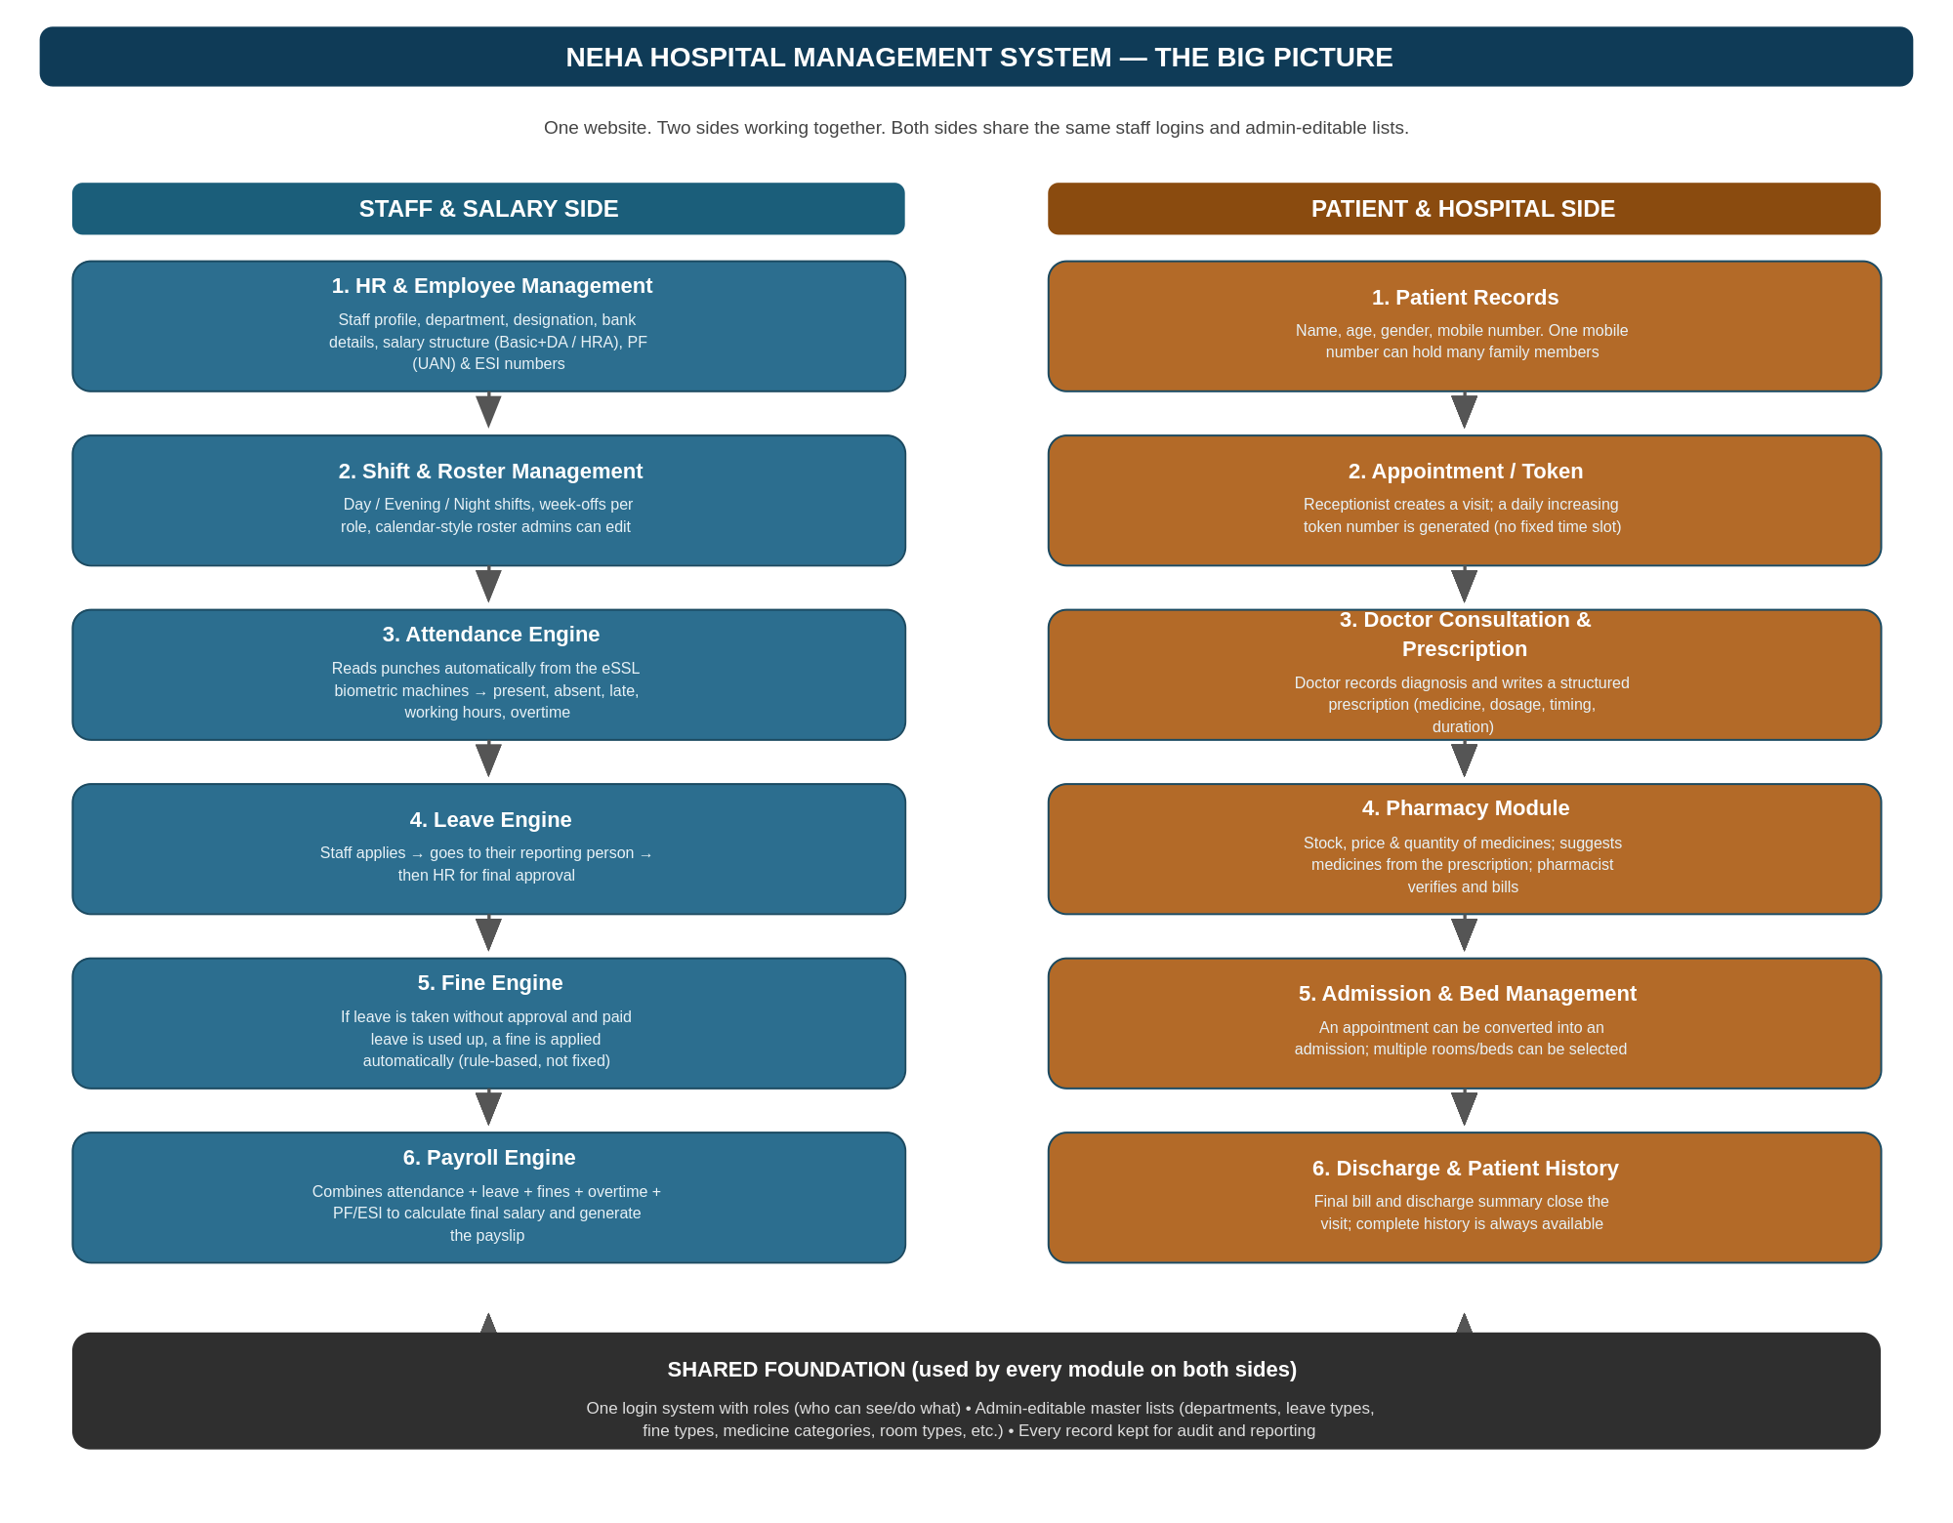
Figure 1 — The two sides of the system and how they connect

How to read this document
Sections 2 and 3 below cover the “Staff & Salary Side” and the “Patient & Hospital Side” — twelve modules in total, exactly as agreed. Each module is explained in three parts: what it is, how it works step by step, and a worked example using realistic numbers. Section 4 covers the parts every module shares. Section 5 is a short plain-language glossary of any technical-sounding words used.

2. The Staff & Salary Side (6 Modules)
This half of the system is about the hospital's own staff — doctors, nurses, technicians, administration, security, housekeeping — from the day they join, through their daily attendance, up to the salary that lands in their bank account each month.
2.1 HR & Employee Management
This is the master record of every staff member — the starting point that every other module in this half of the system relies on.
How it works, step by step:
- Admin adds a new staff member: name, department, designation (e.g. Nurse, Receptionist), date of joining, and bank account details.
- Each staff member is set up with a “Salary Basis” — Monthly Fixed, Per-Day, or Per-Shift — because not everyone is paid the same way (a full-time nurse on a fixed monthly salary vs. a part-time helper paid only for the shifts they actually work). This is explained fully in Payroll Engine (2.6).
- For Monthly Fixed staff, the system automatically splits their salary into two parts — Basic+DA and HRA — because these two parts are used differently when working out PF and ESI.
- PF (Provident Fund) and ESI (a government health-insurance scheme) numbers are stored here too. If a staff member hasn't been enrolled yet, the system simply marks them as “pending” instead of blocking anything.
- If a staff member gets a salary increase, the admin enters the new amount and the date it takes effect — the system automatically uses the old amount before that date and the new amount from that date onward.

Example: New nurse joins, then gets a raise
• Priya joins as a Nurse on 1 June with a fixed salary of ₹20,000/month.
• On 1 October her salary is increased to ₹22,500.
• September's payslip uses ₹20,000. October's payslip automatically uses ₹22,500 — nobody has to remember to change it.

2.2 Shift & Roster Management
Since a hospital runs 24 hours a day, staff can't all follow one fixed “9-to-5, Sunday off” pattern. This module plans who works which shift, and who gets which day off, for the whole month.
How it works, step by step:
- Admin defines the shifts that exist (e.g. Morning 9am–6pm, Night 9pm–6am) once — they don't need to be re-typed every month.
- Instead of every staff member getting the same day off, each role is given a number of week-offs per month (e.g. 4 for most staff), and the admin picks which specific days off suit the roster.
- The month is shown as a calendar staff can click on, not a spreadsheet — clicking a day for a person lets the admin mark it as a shift, a week-off, or a night duty.
- If someone is unavailable at short notice, their shift can be swapped or reassigned without disturbing everyone else's plan.

Example: Planning July for the Nursing team
• 25 nurses need to be rostered: 8 for Morning, 8 for Evening, 5 for Night, with the rest resting or on leave that day.
• Each nurse is entitled to 3 week-offs in July.
• The admin fills the calendar visually, and the system warns if, say, a nurse would end up working 7 days in a row without a break.

2.3 Attendance Engine
This module automatically turns the raw punch times from the eSSL biometric machines into a clear daily record: present, absent, late, hours worked, and overtime.
How it works, step by step:
- Every few minutes, the system pulls the latest punch records from the biometric machines connected over the hospital's network.
- For each staff member, it looks at their first punch (time in) and last punch (time out) for the day and works out total hours worked.
- It compares this against their assigned shift to flag lateness, early leaving, or a missed punch (staff can request a correction, which needs approval).
- Each shift has a configurable “buffer” (grace period) — for example, 10 minutes. Arriving within the buffer is not treated as late; only arriving beyond it is flagged, so nobody is punished for arriving 2 minutes after time.
- The original punch data is never changed — it is only ever read from, so there is always a full, honest trail to check if a query comes up later.
- Extra time worked beyond the shift becomes overtime, which is handed off to the Payroll Engine at the end of the month.

Example: One employee, one day
• Shift starts at 09:00 with a 10-minute buffer, so anyone in by 09:10 counts as on time.
• Raw punches from the machine: 09:08 (in), 13:04 (out for lunch), 13:46 (back in), 18:11 (out).
• System works out: 8 hours 21 minutes worked, 42 minutes break, marked Present and on time (09:08 is inside the buffer).
• If someone leaves 3 hours after their shift ends, that 3 hours is recorded as overtime automatically.

2.4 Leave Engine
This handles staff applying for time off, keeps count of how many paid leave days each person has left, and works out what happens when someone is absent with no paid leave remaining.
How it works, step by step:
- The hospital defines its leave types up front — typically Casual Leave, Sick Leave, Earned Leave, Comp Off, and Half Day — and how many days of each a staff member gets (e.g. 1 Casual Leave per month, 12 Sick Leave days per year). These numbers are admin-editable, not fixed in the software.
- Staff member applies for leave through the website, picking the leave type and dates.
- The request first goes to their reporting person (their supervisor/HOD) for a first check, then to HR for final sign-off.
- The system keeps a running balance per leave type, per staff member — so it always knows exactly how many Casual/Sick/Earned days someone has used and how many remain.
- If a staff member applies for leave but their balance for that leave type is already at zero, the system marks that day as LOP (Loss of Pay) instead of rejecting the request outright — meaning the day is simply unpaid, since they did follow the correct process of applying.
- If a staff member is absent without applying at all, and has no paid leave balance left to cover it, that day becomes LOP and also triggers the Fine Engine (2.5) — because in that case the correct process wasn't followed either.
- Once approved, leave (paid or LOP) is automatically marked correctly in attendance — no manual re-entry needed.

Example: Three different leave outcomes
• Ravi has 2 Sick Leave days left. He applies for 2 days off sick — approved as paid Sick Leave, no LOP, no fine.
• Meena has 0 Casual Leave left this month but still applies properly for 1 day off — it's approved, but recorded as LOP (that 1 day is unpaid), no fine, because she did apply.
• Sundar has 0 leave left and simply doesn't turn up without applying — that day is LOP and the Fine Engine additionally applies a fine, since no application was made at all.

2.5 Fine Engine
This applies a penalty automatically on top of LOP, specifically when a staff member is absent without even applying for leave and has no paid leave left — based on a rule, not a fixed hardcoded amount. It's important to note LOP and a Fine are two different things: LOP just means the day is unpaid; a Fine is an extra penalty for not following the leave process at all.
How it works, step by step:
- The system checks: was leave applied for at all? If yes — whether it's approved as paid leave or turned into LOP — no fine, since the process was followed.
- If nothing was applied for (an unexplained absence), the system checks: does this staff member still have paid leave left? If yes, it's simply counted as paid leave — still no fine.
- Only if there was no application at all, and paid leave was already exhausted, does a fine get applied — using a rule the admin can adjust (the exact fine logic can be refined later — this is deliberately built so the rule can change without rebuilding the system).
- Fines are recorded against the staff member and automatically flow into that month's Payroll Engine as a deduction, separately from any LOP deduction for the same day.

Example: Exhausted leave, then an unexplained absence
• Sundar has already used all his paid leave for the month.
• He is absent for a day without applying for leave or getting approval.
• That day becomes LOP (unpaid) and the Fine Engine additionally applies the configured fine — both show up as separate deductions on his payslip, HR doesn't have to remember to add either by hand.

2.6 Payroll Engine
This is where everything from the other five modules comes together to calculate the final salary and produce the payslip — including the Salary Structure, PF/ESI, and Extra Duty/Overtime calculations agreed as part of this module.
How it works, step by step:
- Every staff member is paid according to their Salary Basis, set on their profile in HR & Employee Management: Monthly Fixed, Per-Day, or Per-Shift — the three calculation methods below.
- Monthly Fixed: staff member has one fixed monthly amount (split into Basic+DA / HRA). Their per-day rate for LOP or fine deductions is worked out as Fixed Salary ÷ total days in that month, and that per-day rate is subtracted for every LOP day.
- Per-Day: staff member has no fixed monthly amount — instead they have a rate per day. Salary for the month = (rate per day) × (number of days actually present, including approved paid leave). No separate LOP calculation is needed since unpaid days simply aren't counted.
- Per-Shift: staff member is paid a fixed rate for each shift they work, regardless of how many hours that shift covers — common for part-time or on-call staff who might pick up an occasional Morning or Night shift. Salary for the month = (rate per shift) × (number of shifts actually worked).
- Whichever basis applies, LOP days worked out by the Leave Engine (2.4) reduce pay accordingly, and any Fine from the Fine Engine (2.5) is deducted separately on top.
- Adds Extra Duty / Overtime — this covers both whole extra days worked and specific hours of overtime tied to a date (e.g. “3 hours OT on 9 June”), both converting to a rupee amount that adds to salary, on top of whichever salary basis was used.
- Calculates PF: 12% is deducted from the staff member's own Basic+DA (capped at a configurable ceiling, e.g. ₹15,000, even if their actual Basic+DA is higher); the employer's matching share is also calculated but paid separately by the hospital, not deducted from the staff member. This applies to Monthly Fixed staff — Per-Day/Per-Shift staff are typically outside PF/ESI, but this stays configurable per employee.
- Calculates ESI in the same spirit: a small percentage is deducted from gross salary, but only for staff whose gross salary is under a configurable ceiling (e.g. ₹21,000) — above that, they are simply marked exempt for that month.
- Produces the final “take-home” salary and a payslip that lays out every one of these numbers clearly, so nothing is a mystery to the staff member.

Example: Three staff members, three salary bases, one month
• Priya (Monthly Fixed, ₹25,000/month, 30-day month): 26 present, 2 approved leave, 2 LOP with no fine. Per-day rate = ₹25,000 ÷ 30 = ₹833. Pay before PF/ESI = ₹25,000 − (2 × ₹833 LOP) = ₹23,334.
• Kumar (Per-Day, ₹700/day): worked 24 days this month (including 1 approved paid leave day). Pay = 24 × ₹700 = ₹16,800. No PF/ESI applies to him.
• Anitha (Per-Shift, ₹500/shift, on-call helper): picked up 9 shifts this month. Pay = 9 × ₹500 = ₹4,500.
• For Priya specifically: add her 3 hours of OT, deduct PF (12% of Basic+DA, capped) and ESI (since under the ceiling), and any fine — the payslip shows every step.

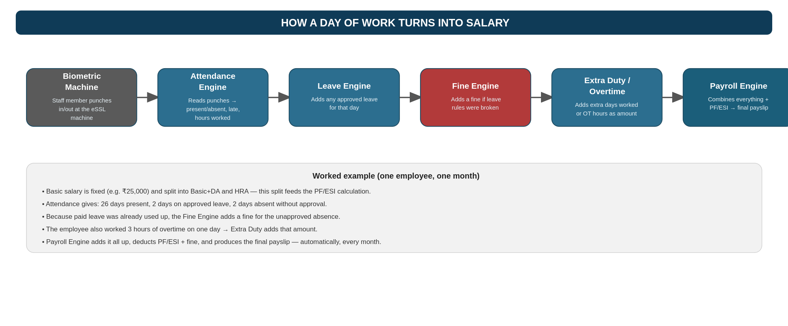
Figure 2 — How one day of work eventually becomes a line on a payslip

3. The Patient & Hospital Side (6 Modules)
This half of the system follows a patient from the moment they walk in, through consultation and treatment, to the moment they leave — keeping one continuous, searchable history.
3.1 Patient Records
This is the master record of every patient, built around their mobile number since that's what reception will always ask for first.
How it works, step by step:
- When someone new arrives, reception enters name, age, gender, and mobile number, and a record is created.
- One mobile number can be linked to several patients — a father might book visits for himself, his wife, and his children all using the same number.
- Whenever that mobile number is searched, the system shows every patient linked to it, asking staff to pick the right person by name and age (so a father and his son aren't mixed up).
- Every patient record accumulates their full history over time — covered in Module 3.6.

Example: One phone number, one family
• The number 98765-43210 is linked to Rajesh (42, father), Lakshmi (39, mother), and Kavin (12, son).
• When a receptionist types that number, all three names appear so the correct family member can be selected for today's visit.

3.2 Appointment / Token Module
This creates today's visit for a patient and gives them a simple, fair place in line — the way most walk-in clinics actually work, rather than fixed time slots.
How it works, step by step:
- Reception looks up the patient (or creates a new one) and creates today's appointment.
- The system gives that visit the next available token number for the day (1, 2, 3…), increasing one by one — there is no appointment time to manage.
- The system also records which doctor the patient will see.
- Booking an appointment for a future date is possible in the system's design, even though the hospital doesn't need to use it yet.

Example: A normal morning at reception
• The first patient today gets Token 1, the next gets Token 2, and so on — whoever created the earliest appointment has the earliest number.
• Doctor Meera is recorded as the doctor for Token 1's visit.

3.3 Doctor Consultation & Prescription
This is where the doctor records what's wrong with the patient and writes a prescription — stored in a structured way so the pharmacy can use it directly, not just as a note.
How it works, step by step:
- Doctor opens the patient's appointment and records the diagnosis and complaints.
- Instead of typing a prescription as plain text, the doctor picks each medicine and fills in dosage, timing (morning/afternoon/night), number of days, and before/after food — in a simple structured form.
- A follow-up date can be added if needed.
- This structured prescription is what allows Module 3.4 (Pharmacy) to automatically suggest the right medicines.

Example: A prescription for a fever
• Doctor diagnoses a viral fever and prescribes Paracetamol: 1 tablet morning, 0 afternoon, 1 night, for 5 days, after food.
• Because this was entered in the structured form (not free text), the pharmacy screen can show this medicine as a one-click suggestion.

3.4 Pharmacy Module
This manages the medicine stock and turns a doctor's prescription into a bill — with a pharmacist always checking before anything is billed.
How it works, step by step:
- Admin/pharmacist maintains the medicine list: name, category, stock quantity, price, and description, so stock levels are always known.
- When a prescription is opened, the system suggests the prescribed medicines automatically from stock.
- The pharmacist reviews and confirms (adjusting if something is out of stock or substituted), then generates the bill, which is linked to that patient's visit.
- One visit or one admission can have several separate pharmacy bills over time, not just one — for example, more medicine bought a few days into a hospital stay.

Example: Billing today's prescription
• The system suggests Paracetamol (from the prescription) already priced and in stock.
• The pharmacist confirms the quantity, and the bill is generated and linked to the patient's visit — ready for payment.

3.5 Admission & Bed Management
When a patient needs to stay in the hospital rather than just visit, this module converts their appointment into an admission and manages where they physically stay.
How it works, step by step:
- Staff converts the day's appointment into an admission with one action — the patient's record and history carry over automatically.
- One or more rooms/beds can be selected for the admission (a patient might need more than one room over their stay, or a room may need to be changed).
- Rooms and beds are managed on their own page, organised as Building → Floor → Ward → Room → Bed, so staff always know what's occupied and what's free.
- The admitting doctor is recorded, just as with a regular appointment.

Example: Admitting a patient to the ICU
• Rajesh's appointment is converted into an admission.
• Staff selects Main Building → 2nd Floor → ICU → Room 204 → Bed A for him.
• That bed now shows as occupied everywhere in the system until he is discharged.

3.6 Discharge & Patient History
This closes out a visit or admission properly, and ties every piece of a patient's care together into one place anyone authorised can look at.
How it works, step by step:
- When the patient is ready to leave, staff writes a discharge summary (diagnosis, treatment given, medicines, doctor's advice, follow-up).
- Staff enters the final amount to be paid, the patient pays, and the appointment/admission is closed at the same time.
- The bed used (if any) is released and becomes available again.
- From that point on, a single click on the patient's record shows their complete history: every appointment, every admission, every prescription, every pharmacy bill, every discharge summary — all in one place, in order.

Example: Closing out a hospital stay
• Rajesh is ready to go home after 4 days in the ICU.
• Staff writes the discharge summary, enters the total amount due, and takes payment — this also closes the admission and frees Bed A.
• Six months later, if Rajesh visits again, the doctor can open his history and see this entire stay in seconds.

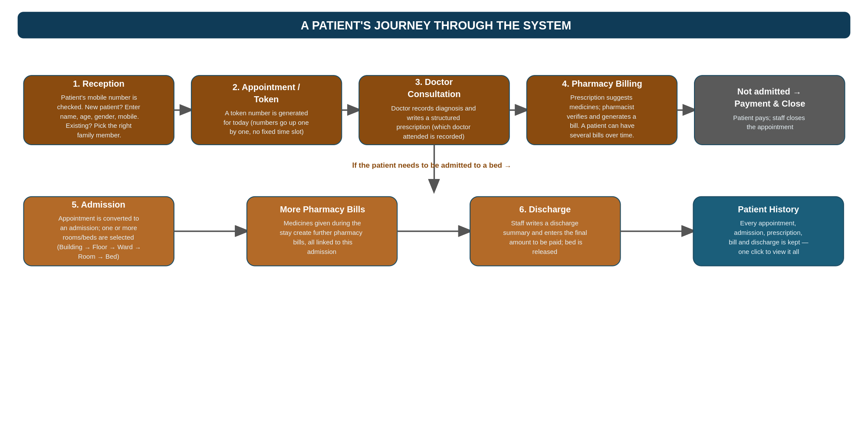
Figure 3 — A patient's journey from reception to discharge

4. What Every Module Shares
A few things sit underneath all twelve modules, rather than belonging to just one. These aren't extra modules — they're the plumbing that makes all twelve work safely together.
- One login for everyone, with roles: A receptionist, a pharmacist, a doctor, and an HR staff member all log into the same website, but each only sees the screens and actions relevant to their job. A pharmacist cannot approve leave; HR cannot edit a prescription.
- Admin-editable lists everywhere: Departments, leave types, fine types, medicine categories, room types — none of these are fixed in the software's code. An admin can add, rename, or remove them from a settings screen at any time, without needing a developer.
- A record of who did what: Important actions (a salary changed, a prescription edited, a bill generated) are logged with who made the change and when — useful if a question ever comes up later.

5. Plain-Language Glossary
A short explanation of the more technical-sounding words used in this document.
- eSSL biometric machine — the fingerprint/face punching device staff use to mark their time in and out; “eSSL” is just the brand of that device.
- PF (Provident Fund) — a government retirement-savings scheme; a small percentage of salary is set aside every month, matched by the employer.
- ESI (Employees' State Insurance) — a government health-insurance scheme for lower-income employees, funded by small monthly deductions.
- UAN — a unique number every PF-enrolled employee has, used to track their PF account.
- LOP (Loss of Pay) — a day an employee doesn't get paid for, usually because they were absent without approved leave.
- OT (Overtime) — time worked beyond the normal shift, paid extra.
- Roster — the plan of who works which shift, and who is off, on each day of the month.
- Token number — the simple, increasing number given to each patient visit for the day, instead of a fixed appointment time.
- Admin-editable / dynamic — something that hospital staff can change themselves from a settings screen, without needing to ask a developer to change the software.

